Tomasz Czubat

CS-350 Final Project Report

10/14/21

The final goal is to develop a thermostat prototype that sends data to SysTec’s server software over Wi-Fi, but first develop a prototype of the low-level thermostat functionality working. CC3220X-LAUNCHXL development board (Texas Instruments) is used for the prototype, the TMP006 temperature sensor is used to read the room temperature (via I2C), an LED to indicate the output to the thermostat where LED on = heat on (via GPIO), two buttons are used to increase and decrease the set temperature (via GPIO interrupt), and the UART to simulate the data being sent to the server. In the end the appropriate hardware architecture is chosen for the application bearing in mind three main factors: support of peripherals, capacity to power Wi-Fi connectivity and enough memory to support the code.

UART, which stands for Universal Asynchronous Reception and Transmission, is a simple serial communication protocol that allows the host (CC3220X) to communicate with serial devices. UART supports bidirectional, asynchronous and serial data transmission. It uses 2 data lines to communicate with each other which are: TX (Pin 1) and RX (Pin 0). TX – Used for transmitting and RX – Used for receiving (Bierl, 2000).

Advantages of UART: Simple to operate and use with the CC3220X. It is well documented online as it is a widely used method by CC3220X users with many resources and tutorials online. No clock needed. Drawbacks of UART include slower speed compared to I2C and SPI, Baud rates of each UART must be within 10% of each other to prevent data loss and cannot use multiple master systems like the CC3220X and slaves.

I2C, stands for inter-integrated-circuit, is a serial communication platform designed for microcontrollers. Compared to UART, it is similar but I2C is not used for PC – Device communication but are used with modules and sensors. It is a simple, bidirectional two-wire synchronous serial bus and only 2 wires (SDA and SCL) to transmit information between devices connected to the bus.

With I2C, they are useful for projects as they would sometimes require many different parts (eg. sensors, expansions, drivers) working together and with I2C, you can connect up to 128 devices on the mainboard while maintaining a clear communication pathway between the master (launchpad) and slave (Modules and sensors) devices.

Advantages of using I2C: Low pin/signal count even with many devices on the bus, supports multi-master and multi slave communication. Simple since it uses only 2 wires and adapt to the needs of various slave devices. Disadvantages of using I2C: Requires more space due to the use of resistors and can get complex as the number of devices increase (Yang, 2011).

The following three steps have been used to connect to cloud

* Initialize device.
* Connect device to Wi-Fi Access Point using SimpleLink API’s.
* Create socket to cloud using SimpleLink API’s.

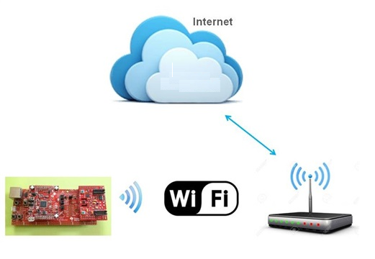

Fig 1: connection steps to cloud

SimpleLink™ Wi-Fi network processors (NWP) to an existing host MCU to enable cloud connectivity with features including: Has 256KB RAM and 1GB flash memory

WIFI Architecture

The following are the key factors to be considered when choosing a WIFI architecture:

* Security
* Protocol supported and its operating frequency band, transmission range
* Transmission power output, operating supply current or voltage
* Data rate (max throughput)

Freescale

•Memory footprint

−100 KB flash and 12 KB RAM for a full application and profile (including KSDK, RTOS and drivers)

−70 KB flash and 4 KB RAM just the stack itself

Texas instruments

It has a wireless MCU with a 32-bit ARM Cortex-M4 processor that allocates WiFi and world wide web algorithms from the application processor. The WiFi network processing subsystem includes a WiFi internet-on-a-chip on a chip with WPA2 security that runs at 2.4 GHz. An 802.11b/g/n radio transmitter, and MAC with a powerful crypto processor for protection are also included. It has many peripherals, including UART, SPI, I2S, I2C, ADC, and others. ROM with external memory bootloader and drivers, as well as configurable onboard RAM for source code, are included in the CC3200 Device series (Beneteau et al., 2014).

*SAMW25 by Microchip*

Microchip's SAMW25 is a WiFi IoT solution. The host program, which contains the API and an SPI driver for communicating with the onboard WiFi SoC, is executed on the SAMD21 ARM Cortex-M0 plus MCU. The WiFi module is powered by the WINC1500, an IEEE 802.11 b/g/n IoT network controller with integrated TCP/IP and WiFi stack that consumes very little power (Barrett & Pack, 2011). This module also features a 4 Mbit internal flash memory with OTA firmware updating, as well as host interfaces such as SPI, UART, and I2C, as well as a variety of other peripherals. It can function totally host-less in most systems and offers WiFi Direct, station mode, SoftAP, network protocols (DHCP/DNS), including secure TLS core.

The chosen hardware architecture is the Texas instruments architecture since it offers the best security and this is important to support business operations. Moreover, TI focus on quality and robustness when manufacturing hence it will last longer.

**References**

Barrett, S. F., & Pack, D. J. (2011). Microcontroller Programming and Interfacing Texas Instruments MSP430, Part II. Synthesis Lectures on Digital Circuits and Systems, 6(2), 1-232.

Bierl, L. (2000). MSP430 family mixed-signal microcontroller application reports (pp. 478-480). Texas Instruments

Yang, L. D. (2011). Implementation of a wireless sensor network with EZ430-RF2500 development tools and MSP430FG4618/F2013 experimenter boards from Texas instruments

Beneteau, A., Di Caterina, G., Petropoulakis, L., & Soraghan, J. J. (2014). Low-cost wireless surface EMG sensor using the MSP430 microcontroller. In 2014 6th European Embedded Design in Education and Research Conference (EDERC) (pp. 264-268). IEEE.